Compiled by Roger Pfister http://RogerPf.com/bridge roger@rogerPf.com

Marty Bergen's book – Slam Bidding Made Easier – introduced a deeply clever Hand Evaluation methodology. I think of this approach as being the – Milton Work Count on steroids.

There is a fantastic tutorial on Bergen Hand Evaluation at http://www.bridgesights.com/hondobridge where this 'Bridge Movie' can be played on line.

Alternatively download the bridge movie by clicking on the bold link above. It can then be played on your computer with the free aaBridge Movie player from http://rogerpf.com/aaBridge

Note – aaBridge is my work and I am proud of it. However I am in no way associated with the hondobridge website. But I did indeed write aaBridge in order that I could play, on my own computer, all of the many hundreds of fantastic bridge movies that can be found there. (Update - most of the movies are now built into aaBridge).

I see this document as a supplement to the above tutorial. The clear explanations and examples contained in it are as good as it gets when it comes to describing how to calculate Bergen's Starting, Dummy and Declarer points.

High Quality LAD is my attempt at an answer. (The best thing is, for you to start the tutorial and then return here once you are asked to do your own full calculations).

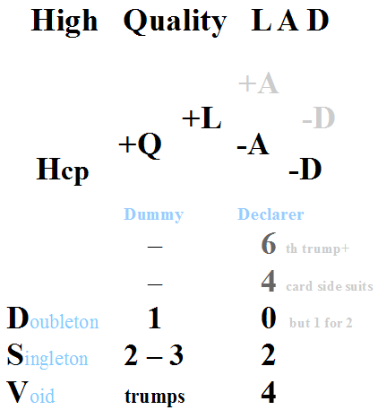
The image on the left is a mind picture. Literally the picture I bring to mind when I calculate Bergen style. You will have read some of the Bergen Hand Evaluation tutorial so you should already be familiar with the following –

Hcp – High Card Points.

Quality – 3 of the top 5 (in 4 card suits only) +1 each suit.

Length – 5th, 6th ... card in any suit +1 each card.

Adjust3 – Adjustment for too many Queens and Jacks ±N
often zero. As in the picture, it can go up or down.

Dubious doubletons – Qx, Q, Jx, J, KJ, ... -1 for each.
Always goes down (or is zero). Dubiousness
evaporates if partner shows that suit.

Once you know there is a fit (3+ cards in short trump hand) you can add values for the fit. Dummy (short trumps) is the simple case – you only add for D S V hence the dashes in that table. For a Singleton you add, 2 pts if you have only 3 trumps and 3 pts with 4 or more. With a Void, you add the number trumps as points. Declarer (long trumps) gets to double dip with the trump suit +1 for the sixth and any subsequent trumps. +1 for any other 4+ card side suits. Just remember the pattern 6 4 0 2 4 and that dummy is the simple case.

Bergen Ranges | Open Min | 13 - 16 |  | Responder Min | 6 - 9 |  | Game | 26
 | Med | 17 - 19 |  | Inv | 10-12 |  | Slam | 33 + controls
 | Max | 20+ |  | Max | 13+ |  | G S | 37 + controls

